Build Log

System overview:
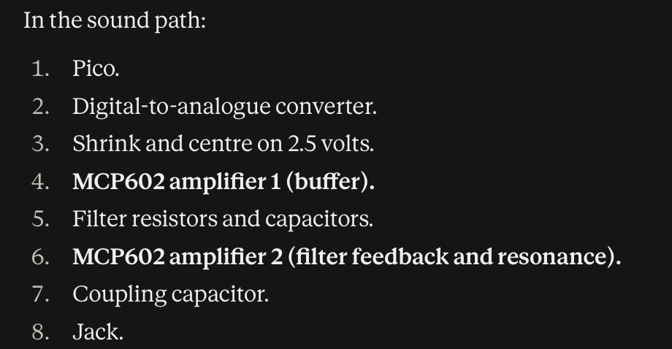
(Redo on paper)
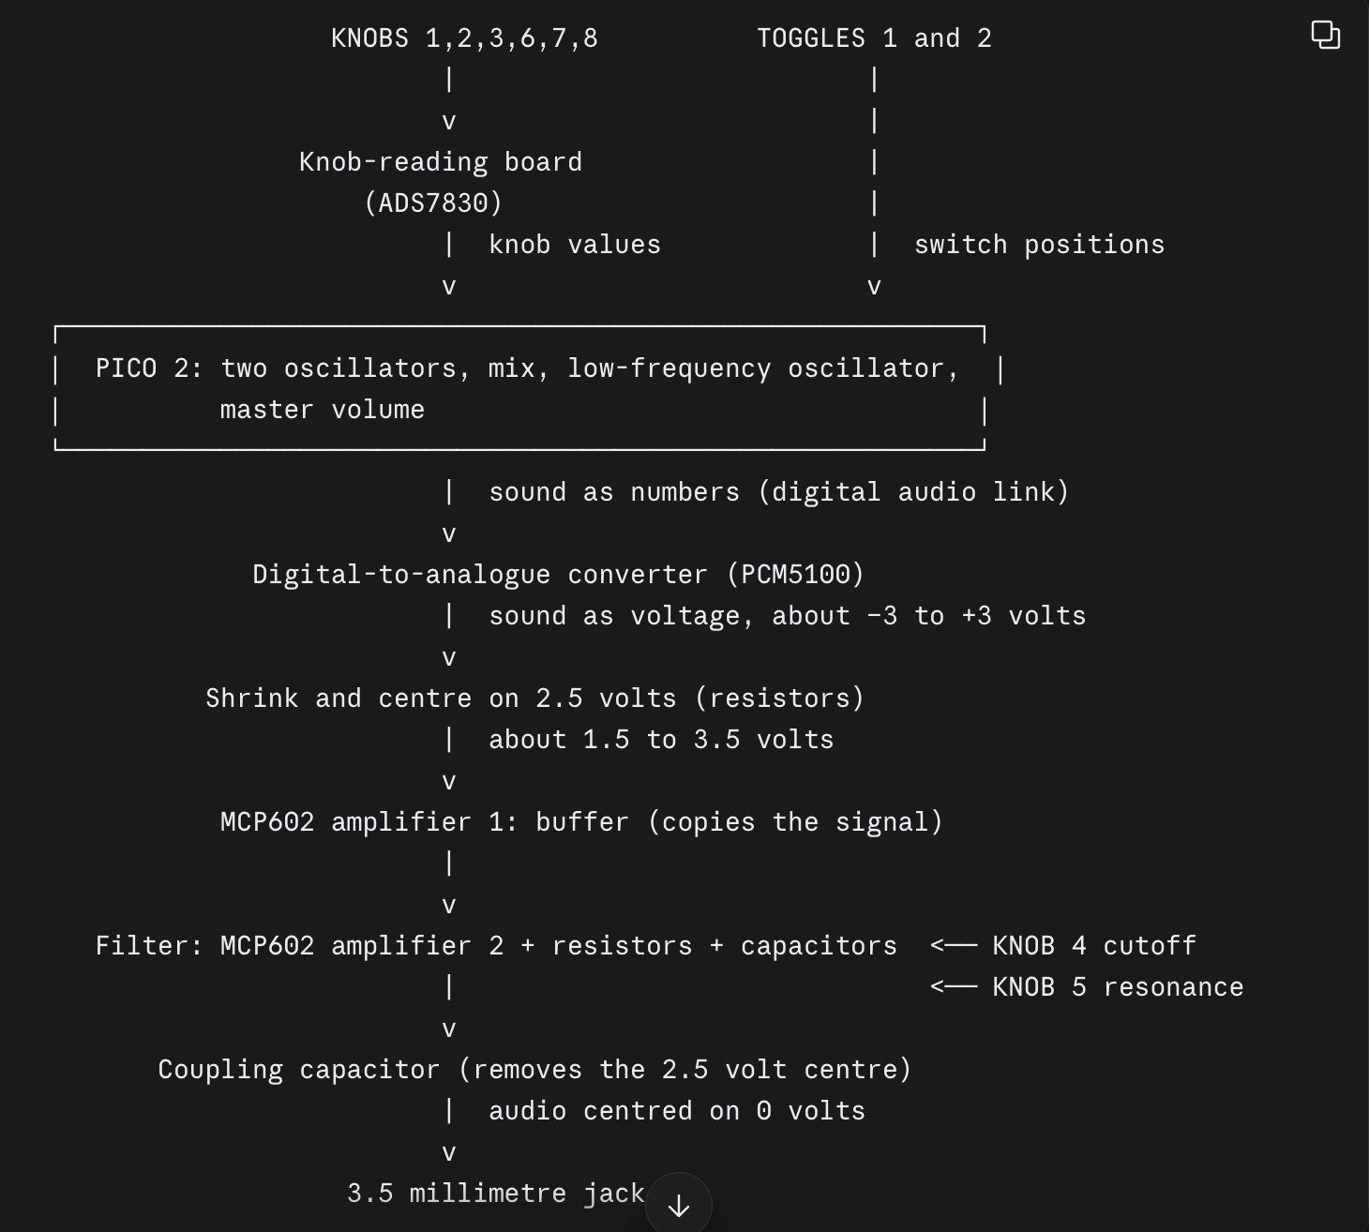(Redo on paper)

What each knob will be for:
Knob | Control | Part | Legs | What it connects to
1 | Oscillator 1 pitch | 10 kilohm linear, with on/off switch | Right-angle | Knob-reading board
2 | Oscillator 2 pitch | 10 kilohm linear, with on/off switch | Right-angle | Knob-reading board
3 | Oscillator mix | 10 kilohm linear, with on/off switch | Right-angle | Knob-reading board
4 | Filter cutoff | 100 kilohm dual-gang (Alpha) | Right-angle | The audio path itself (the filter)
5 | Filter resonance | 10 kilohm logarithmic | Straight | The audio path itself (the filter)
6 | Low-frequency oscillator rate | 10 kilohm linear, with on/off switch | Right-angle | Knob-reading board
7 | Low-frequency oscillator depth (moves the mix) | 10 kilohm linear, with on/off switch | Right-angle | Knob-reading board
8 | Master volume | 10 kilohm linear, with on/off switch | Right-angle | Knob-reading board

Build Requirements:

Requirement: | Starting target: | Measured with:
Oscillator pitch range | C1 (32.7 hertz) to C6 (1046.5 hertz) | Oscilloscope frequency reading
Tuning | Within 5 cents of the note (a cent is one hundredth of a semitone) | Oscilloscope frequency reading, converted to cents
Waveforms | Sine, saw and square on each oscillator | Oscilloscope shape
Mix at each end | Other oscillator at least 40 decibels quieter | Oscilloscope frequency view, or MATLAB
Mix loudness | Steady within 1.5 decibels across the knob | Oscilloscope signal-strength reading at 9 positions
Low-frequency oscillator rate | 0.1 to 20 hertz, within 5% | Timing one cycle
Low-frequency oscillator depth | 0 to 100% of the mix range | Printing the mix value to the computer
Master volume | Silent at minimum, even-feeling across the knob | Oscilloscope and listening test
Filter cutoff | About 150 to 10,000 hertz, within 15% | Frequency sweep with the function generator
Resonance | Quality factor about 0.7 to 5, never self-oscillating | Frequency sweep; silence test
Output level | At most 0.5 volts signal strength (root mean square), no clipping | Oscilloscope
Knob-to-sound delay | Under 20 milliseconds | Two-channel oscilloscope
Supply | Works from 4.75 to 5.25 volts; current below your calculated budget | Lab power supply; multimeter

Risk Register:
Risk: | Mitigation:
PCB arrives late or wrong | Continue to use breadboards and solder all pins in, cleaning up any debris and checking voltage levels + drops across components
DAC output level is too high for the op-amp
MCP602 input range limits the signal | Order another that has a larger input range or reduce input signal value
8-bit knob readings cause audible steps | Smooth each reading in the firmware: average several readings, ignore changes of a single step, and glide the sound parameter gradually towards its new value instead of jumping.
I2S pin constraints clash with your pin map
Two halves of the dual-gang pot don’t track and shift the cutoff | Measure both halves at several positions with the multimeter when the parts arrive (step 1.1). Model in MATLAB how much mismatch your filter can tolerate. If it’s outside that, add a small resistor in series with one half to balance them, or replace the pot. If it’s inside, record it as acceptable with the measurement as evidence.
Audio noise | Set GP23 high at start of the code to reduce background hiss
LFO on the oscillator mix is inaudible when both oscillators are identical | Expected behaviour, not a fault

LogBook:
2/11/26 –
Ordered all the required components from pi hut + switch electronics, installed Arduino IDE, multimeter use and 3D printer use, Created and organised a Folder to place all files I may make during the project building. Created a timely checklist of steps for the project. Emailed lab technicians about scope bench time. Identified data to research before components arrive.
3/11/26 – Created a initial build requirements + risk register tables, updated checklist to hit more viable timeframes, completed an initial bill of materials document.
4/11/26 – Completed a datasheet values document to be used for reference as I make the physical build + code, it prevents parts from breaking due to voltage overload and helps decide resistor values and placement. Identified pico 2 pin GP23 in datasheet, and how I should set it on high when first beginning the code, in order to force the regulator into low ripple mode which reduces background hiss and noise. Also added a watch out for section in the datasheet.
5/11/26 – Downloaded and created accounts for all the software that I will use in the project, being the Arduino IDE, Github and MATLAB (Allready had fusion 360 CAD downloaded from previous University work). Created a Github repository for the project and pushed the first commits, also made it public for any future employers to access. Acquired a multimeter for testing of parts.
6/11/26 – Retouched on voltage dividers (using practical electronics for inventors book) in circuits and worked out values for two circuits with different resistor totals for a later step when beginning to make the breadboard circuits.
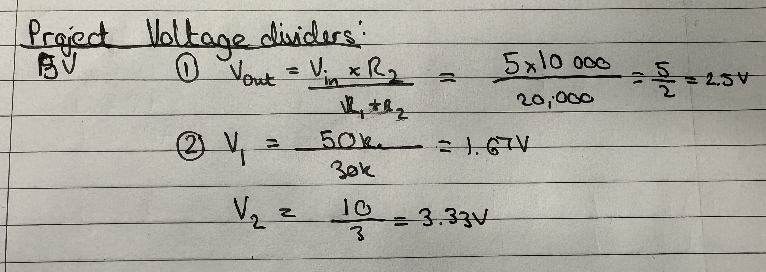
Added another step after 1.1 to draw the whole planned circuit before beginning to make it, as this will make the build easier to do and edit down the line should values need to change.
Touched on capacitor coupling, these act to pass a range of ac signals from one circuit to another without letting through dc components pass. To make it effective the capacitor’s impedance needs to be as low as possible at my frequency range of interest. I made a note of the equations for this in the datasheets document. Also looked at bypassing (decoupling), which are capacitors used for bypassing undesired ac signals, such as noise which can present problems by presenting improper voltage levels to the I2C supply lead, or any other chips.
Created another document stating all the electronic rules to consider during the project, so that I can quickly refer to and memorise them all, this was done to make it easier for creating the circuits and debugging values. Added another section to each step in the checklist document so that it includes which electronic rules to use.

